A Jeffersonian Uproar:
Digital Analysis of “State Rights,” 1800-1860

Raphael Governali
HIST-677: History and New Media
April 6th, 2021

Introduction:

Among the most enduring American political debates is the clash between state rights and federal rights. Since the ratification of the Constitution in 1788, two political philosophies have guided American political thought: those who believed that the power of the government should be expanded, and those who believed it should be contained, and even limited. The small government argument is rooted in the belief that the Constitution was formed by a compact between the states, and as such, the federal government should act with the consent of the states. This principle of state rights remains pertinent through the present day, with many right-wing politicians justifying their decisions on federal action depending on whether it is in accord with this principle of state rights or not. In fact, some Americans have gone so far as to elevate the concept of state rights from political philosophy, to a way of life, taking pride in their resistance to perceived central government overreach. One would be hard-pressed to find a similar championing of federal rights and powers, at least not directly. Being that this principle has persisted throughout American history, and into the present day, there are several questions that come to mind. Who advocated for state rights? Under what circumstances did they invoke state rights? And how might these people’s understanding of state rights changed overtime?
These questions were the source of inspiration for this paper, and served as the guidelines for inquiry into the subject of state rights. Because the concept has had a lifetime of over 230 years, it would be impossible to explore these questions over the entirety of American history within the limitations of an essay. As such, this paper will focus upon the time between 1800 and 1860. This period was chosen for several reasons. Firstly, the extent of federal powers would remain relatively muted up until the Civil War, when President Lincoln took unprecedented actions to prosecute the war, and opened the door to increasing federal power thereafter. A second reason is that this period of time was host to a number of constitutional crises, which brought the issue of state rights to the forefront of American life. Finally, certain analytical tools that were utilized in this study are limited to a start date of 1800.
This paper will demonstrate that, during the period of time that was studied, Southerners, and Democratic Party members more broadly, were the predominant advocates of state rights, and that these advocates’ relationship to state rights was an opportunistic one. To do so, this paper will explore findings from a number of newspapers and re-printed speeches, taking into consideration the political contexts under which they were created. Furthermore, this paper will examine the digital analytical tools that were used to collect research data, the search criteria used with these tools, and finally, the liberties and liabilities of using such digital analytical tools.

Digital Analytical Tools
In the aforementioned section, it was noted that data and research material for this project were collected using digital analytical tools. These two tools, Google’s “Ngram Viewer,” and the Library of Congress’ “Chronicling America” database, allowed for the discovery of statistical information, and access to literary materials, respectively. The utilization of these tools allowed for a rapid, and voluminous, collection of information, contrary to more traditional methods of historical analysis.
Google Books Ngram Viewer (referred to here as just “Ngram”), is an analytical tools that allows users to find the frequency of a given book title among the millions registered with Google. Ngram gives users a number of different search criteria to refine results, such as start/end years, corpus, smoothing, and case sensitivity. Once the titles and criteria are set, the results will be displayed both in the form of a percentage out of all logged book titles, and a line graph, which helps to visualize and compare multiple search results against each other. However, correct utilization is not the only consideration one needs to make when using Ngram, but also how selecting longer periods of time to search can “dilute” results, making the line graph appear more smoothed out, and thus, making it more difficult to visualize trends between different results.
All of these considerations were important in the utilization of Ngram for this project, since the slightest deviation between criteria could create drastically different results. Because of this, carefully selected keywords, criteria, and scenarios were used to enhanced search results. For instance, a search for “State Rights,Tariff,Tax” over the period of 1800-1860 might result in the graphed lines being flat, since the sample size would now be larger. To avoid this issue, the studied timeframe was broken up into three equal segments: 1800-1820, 1820-1840, and 1840-1860. Another consideration was the corpus criteria. Because the corpus option defaults to “English” and not “American English,” the results could be influenced by books from other countries, and as such, skew the results. Finally, the searched words had to be strongly considered, since words that are too frequently used compared to other results will flatten other graphed lines.
The other analytical tool used, Library of Congress’ “Chronicling America,” is a database that allows users to search for digitized American newspapers published between 1777 and 1963. Like Ngram, Chronicling America has a number of search criteria to refine results, such as state of publication, newspaper, date range of publication, and specific key term criteria, such as “with any of the words,” “with all of the words,” “with the phrase,” and “within 5 words of each other.” Once entered, it displays the number of results that match the criteria, and displays the newspapers, which can then be viewed with the key terms highlighted. Because these key terms are highlighted on the page, it allows the relevant information to be easily discernable from irrelevant information.
In regards to this project, the depth with which results could be vetted, particularly by state of publication, gave Chronicling America certain advantages over Ngram. By being able to search by state, it was possible to analyze differences of opinion on state rights between the North and the South, and to investigate the extent to which the North even referred to state rights. Ngram, on the other hand, only searches by all American publications, making no distinction between regions. Another advantage of Chronicling America is that it allows users to define the relationships between the selected key terms, whereas with Ngram, there is no distinction made, it only generates results based on the presence of those terms in book titles.
Used together, these two tools allowed for the mapping of complex analytical results, and the rapid procurement of primary source material. Whereas the traditional methods of tracking such trends, such as the reading of hundreds of primary sources from all across the US, would have been tedious and impractical, digital analytical tools like Ngram and Chronicling America allows historians to do it in a matter of seconds. As it was previously mentioned, Ngram was first used to visualize certain “flashpoint” years, when mentions of “state rights” in books increased, as well as the usage of both negative and positive terms, like “tax,” “tariff,” “slavery,” “peace,” “freedom,” ect. This not only allowed the years of “state rights” activity to be plotted visually on a line graph, but it also helped to show the terms that had either a similar or an inverse relationship to “rights.” Then, Chronicling America could be used to explore the newspapers of those flashpoint years to determine what people in specific sections of the country thought about state rights, and why they were concerned with it. In this way, answers to the guiding questions of this project were discovered. In the sections that follow, the findings for the three timeframes studied will be discussed.

1800-1825:
During this first timeframe being studied, the main flashpoint centered around 1824-1825. The Ngram results for “State Rights” indicates that between 1823 and 1825, references to the phrase in book titles increased more than 29%. Interestingly, there did not appear to be any other phrases with a relationship to this spike in “state rights” mentions. However, considering that 1824 was an election year, one with a former Federalist running for president, it can be interpreted that this is the cause for the rise in references to state rights in and around that year.

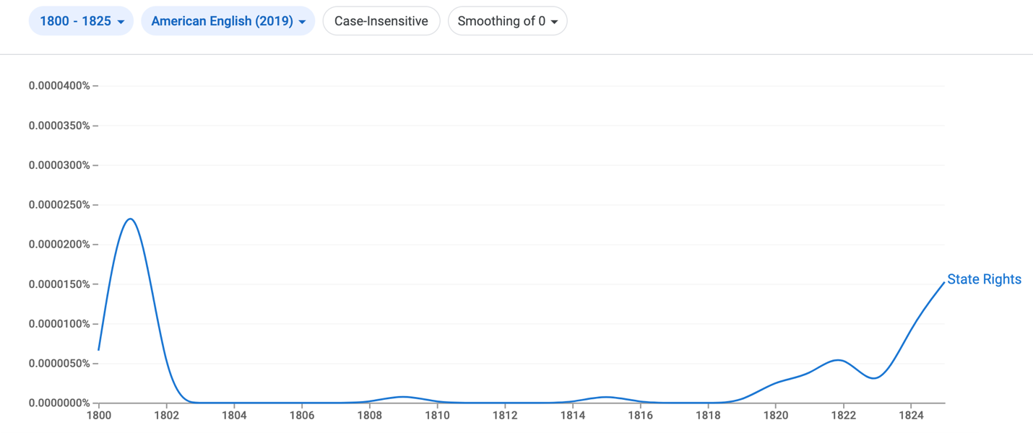
Figure 1 Ngram Results for "State Right," 1800-1825

The Chronicling America results were far more telling. A search result for “State Rights” from 1800-1825 in Northern newspapers vetted only 5 results, all of which were references to speeches given by southern advocates of state rights, and all of which were meant to ridicule such advocates. For instance, in the Portland Gazette for April 21, 1821, the extract of a speech regarding a Bankruptcy Bill is published. The author of the speech, a senator from Maine, argues that the bill is an example of the “constant encroachments of the federal on the state governments,” and calls upon a “gentleman from Virginia…the peculiar guardian of state rights,” to fight against the bill. This would seem to suggest that an attempt at reform, in this case bankruptcy reform, is perceived by state rights advocates as an example of the central government attempting a seizure of power. However, the Gazette appears to ridicule the author of this speech, since “a majority of the Senate finally voted for it; which leads to the conclusion that they were either very wicked or Mr. Holmes somewhat disordered in his fancy or licentious in his rhetoric.” As this shows, not only were northern newspapers’ references to state rights limited, but those that did reference it often did so in a manner of ridicule, a trend that will continue throughout the rest of the period studied.
The Southern newspapers, on the other hand, took the matter of state rights far more seriously, which is evident in the 245 results that turned up for the phrase, a large increase from the 5 noted for Northern newspapers. The cause de celebre for these newspapers appears to be the election of 1824, in which John Quincy Adams, a former Federalist, ran for president. Because of Adams’ former party affiliations, these Southern newspapers claimed that Adams stood contrary to the principle of state rights. In the Alexandria Herald of January 29, 1823, this is put on display, when a letter to the editor denouncing Adams is referenced to. In it, the author, called “Aristides,” argues that Adams should not be elected as president because he “once espoused federal principles,” and as such, “is opposed to state rights.” Here, state rights is being invoked not as its own political principle, but rather, as diametric to opponents of the Democratic nominee for president.
Another example of state rights being defined by its opponents is put forth in the January 22, 1825 issue of the Central Gazette of Charlottesville, Virginia. In that paper, an article titled “Political History” claims to provide a political history of the United States, from 1777 to 1825. In it, the Federalists are accused of desiring “to abolish and annihilate all state governments, and to bring forward one general government…of a monarchial nature,” and of trying to create a “great and energetic nation.” Once again, Federalism, and its advocates, are cast as the foil to states rights. If this is the case, then it follows that the author believes state rights to be about a subdued central government, subordinate to the will of the states.
As these findings indicate, the issue of state rights during the period of 1800-1825 was primarily dominated by newspapers in the South, who invoked state rights either in response to attempts at reform, or as a foil to opponents of the Democratic Party. In the case of the Bankruptcy Bill article, hostility to any change enacted by the federal government appears to be one cause for state rights being invoked, and the association between Southerners and state rights advocacy is also established in that article. In the second article, proponents of federalism are presented as a foil to the ideals of state rights, and as such, lay the ground work for the later utilization of state rights to “other” political opponents. The next section will explore the nature of state rights for the period of 1825-1850, which captures to landmark events: the Tariff of Abominations, and Worcester v. Georgia.

1825-1850:
As it was shown in the previous section, references to state rights was fairly muted until the election year of 1824, when it became more hotly debated. In the period of 1825 to 1850, this trend accelerated drastically, coming to a head in the years 1830-1832, when two significant events occurred: the passage of, and objection to, the Tariff of Abominations, and the Supreme Court’s decision to uphold tribal sovereignty in Worcester v. Sanford. This is supported by the Google Ngram search for the terms “Tariff,” “Supreme Court,” “Decision,” and “state rights,” with references to all of these terms peaking during those years. To illustrate this, the Ngram result for “State Rights” shows that between 1827 and 1830, references to state rights increased by nearly 10% from already elevated levels.

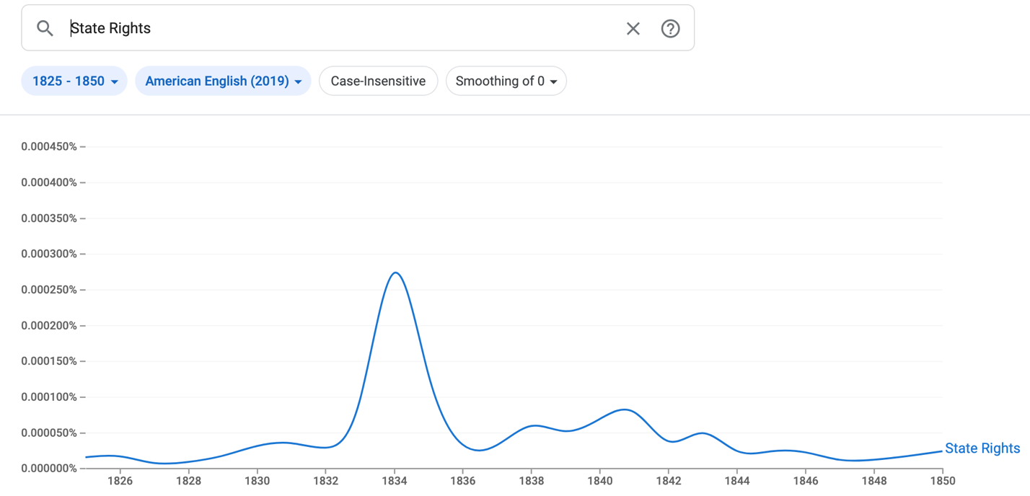
Figure 2: Ngram Results for "State Rights," 1825-1850

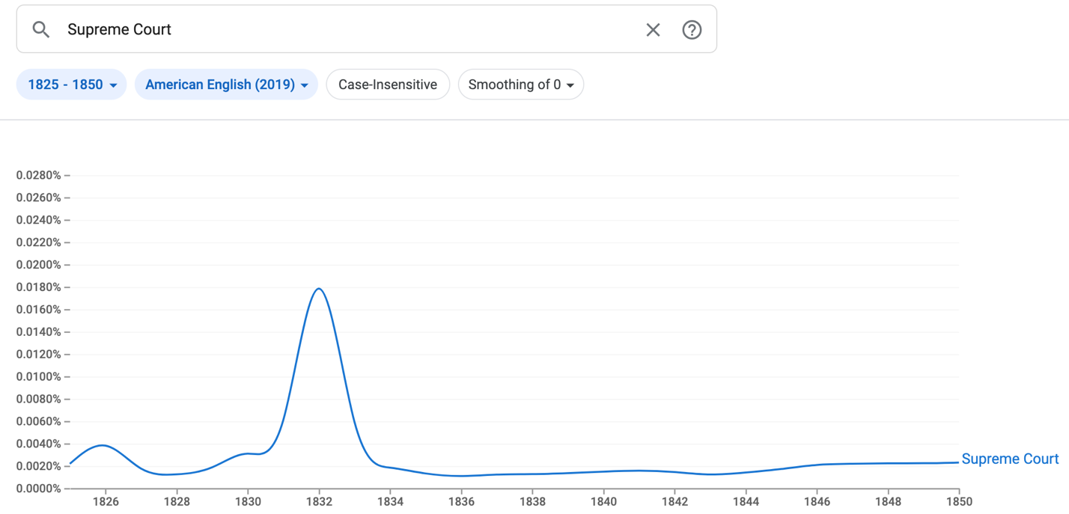
Figure 3: Ngram Results for "Supreme Court," 1825-1850.

The Chronicling America results reaffirm the Ngram findings that Americans understanding of state rights was tied to their opposition of the Tariff of Abominations, and the Supreme Court decision on tribal sovereignty. As in the 1800-1825 section, results for “State Rights” were primarily found in Southern newspapers. This time, however, the number of results increased from 245 to 1025, up 780. This dramatic increase in Southern newspapers’ references to state rights reflects not just its growing public support, but also, when taken in the context of the Ngram results, how Americans understood the concept of state rights. Take, for example, the Virginia Advocate of July 23, 1830. In it ran an opinion section where one contributor wrote that the tariff “cripples our commerce and taxes the many for the benefit of the few. All are injured by it, excepting the manufacturers,” and goes so far as to advocate for an armed resistance, since “a sovereign State, under its reserved rights can…resort to it.” Here, state rights are understood to be a bastion against actions by the government that harm people economically. This would seem to fall in a similar line with the “Bankruptcy Bill” article from the previous section, in that any action by the federal government beyond its existing capacity is seen as an attack on state rights, regardless of whether the rights of the states are diminished by those actions or not.
As in the case of the Tariff of Abominations, the Supreme Court’s decision on Worcester v. Georgia was perceived by Southerners as an attack on state rights, and as such, justified open rebellion if necessary. Search results for “All of: Indians, State, Rights” as well as the phrase “Supreme Court” numbered 450, with at least 25 containing the word “Rebellion.” This shows that by the 1830s, the concept of state rights began to be understood by its adherents as a militant political philosophy if necessary. In the Martinsburg Gazette and Public Advertiser of Virginia, this is displayed in the section “Rebellion!,” where it is suggested that because of big government overreach such as the Supreme Court decision, that the US should return to “the glorious Old Constitution – when each state did what was right in its own eyes” so that Southerners and state rights advocates could “escape yankee misrule.” The article continues to argue that if such a goal is not achieved, that the result must be the practicing of the doctrine of nullification, and subsequently, warfare. This article not only articulates the increasingly militant nature that state rights is being understood by, but also that support and opposition to state rights was becoming increasingly a North vs. South issue, at least in the eyes of state rights advocates.
As such, it can be seen that the period between 1825 and 1850 marks an evolution in the way state rights were perceived by Americans, particularly, that it was becoming increasingly associated with militancy and the North-South dichotomy. Although the frequency that state rights was being invoked decreased after the conclusion of the Nullification Crisis in 1833, it would once again surge in the 1850s, as the country dealt with several political crises throughout that decade, culminating in the Civil in the 1860s. The final section will analyze two specific political crises, namely the Kansas-Nebraska Act and the Supreme Court decision on Dred Scott v. Sanford, and how these crises impacted Americans understanding and relationship with state rights.

1850-1860:
Like the 1820s and 1830s, the 1850s was a decade of political crises and intensity. However, unlike those decades, there were seemingly no solutions to the problems facing Americans in the 50s, and many seemed to lack interest in finding a solution anyways. This held true for advocates of state rights, who by this time were almost exclusively Southerners. Two major flashpoints drove Americans towards ever divided ends: the Kansas-Nebraska Act, and the Supreme Court decision on Dred Scott v. Sanford. The former, which stipulated that the status of slavery in the territories should be determined by popular sovereignty, effectively repealed the Missouri Compromise of 1820, an agreement that was popular with both state right advocates and advocates of federalism, respectively. The latter was a Supreme Court decision that slaves could not be freed simply for being moved to free states, which essentially extended slavery to the free states.
Predictably, the Ngram results for 1850-1860 capture the essence of a country on the brink of war. The results for “State Rights,” “War,” “Abhorrent,” and “Threat,” all demonstrated a correlation to one another, with 1857 being a year where there was a noticeable rise in the usage of these terms (this is the year that Dred Scott v. Sanford was decided). Especially telling is the results for the term “Peace,” which decreases drastically as the decade progresses, further reflecting the environment of hostility.

Because of how the Dred Scott decision interfered with the laws of the Northern free states, it should come as no surprise that the Chronicling America search results for “State Rights” among Northern newspapers exploded during this decade. Whereas searches for prior decades yielded several dozen results at most, the search result for 1850-1860 numbered 2024, which is more than there was among Southern newspapers for the period of 1825-1850. Although it is an outlier among the data already presented, nonetheless it is significant that Northerners became greater participants in the conversation surrounding state rights during this decade, especially in the context of Dred Scott. Even more interesting is the fact that among the Northerners making reference to state rights, abolitionist newspapers make up the greatest share. While abolitionist engagement with state rights is mainly one of opposition and ridicule, it shows that it was become increasingly perceived as a threat by Northerners, and thus, part of how they understood it.
For instance, in the Anti-Slavery Bugle of Ohio, under the article “’Consolidation’ and ‘State Rights,’” the author identifies the Southern conceptualization of state rights as “claims for the State Governments the right of chattelizing their inhabitants,” and that, because the rights of the state are contingent upon the rights of the people residing in them, slavery is a denial of all state rights. This not only demonstrates the increasing Northern engagement with state rights, but also how the very concept was becoming identified with slavery, and the argument for maintaining or extending slavery.
Like the previous article, and the earlier “Bankruptcy Bill” article, The Ottawa Free Trader, an Illinois newspaper, questioned the arguments being made by state rights advocates, namely, justifications for militancy . In the section titled “Jeff. Davis Speech Reviewed,” the author notes that in a recent speech, Davis suggested that “state rights” are unconstitutional, and as such, advocates for it needed to turn to “the last alternative.” The author argues that state rights were in fact consistent with the constitution, and that Davis’ use of it is merely an excuse to advocate for violence. Once again, this excerpt highlights the increasingly militant nature of state rights, and a greater depth of interaction with it by Northerners.
Although Northerners became more involved with the debate surrounding state rights, Southerners easily carried the majority, with 8015 results for “State Rights” in those states for the decade of 1850-1860. In addition to becoming increasingly utilized as a justification for militancy, state rights had an affiliation with the disintegration of the Democratic Party in the years leading up to the election of 1860. As rival factions within the Party began jockeying for power, several factions began legitimizing their claim to the Democratic mantle by asserting their unmatched devotion to state rights. For example, in the Southern Sentinel for November of 1857 ran an article throwing support behind one such faction, aptly called “The State Rights Democracy.” Furthermore, the article calls upon other Democrats to throw their weight behind the State Rights Democracy who will “emerge forth and stand firm and erect upon the true basis of State Rights.” As this shows, faith in state rights became a calling cry for Democrats not just in the fight against federal action, but against competing inter-party factions as well.
Another article highlighting the centrality of state rights to the inter-party conflict in the Democratic Party can be found in the Yorkville Enquirer of December 1858, which ran an article on the comments of a Southern senator and a Southern colonel, who both showed support for the State Rights Party. The article argues against opposition to the Party, saying that “we cannot consent to a division and distraction of the State Rights Party.” The article then closes with a proclamation of who is a true advocate of state rights: “If by a State Rights man is meant one, who, in addition to well known State Rights principles, is not in policy a Unionist per se, but is ready and disposed for a Southern Confederacy…then Senator Hammond is a State Rights man.” This is a significant proclamation of who is a state rights advocate, since it suggests that in order to be one, you must believe in the policy of state rights, be Southern, and be ready to break away from the Union. As such, this article can be thought of as the logical conclusion for the evolution of state rights during the timeframe that this paper studied.

Conclusion:
Thus, this paper has investigated and answered the guiding questions that were presented in the introduction. From 1800 through 1860, it has been shown that the primary proponents of state rights were Southern Democrats, although engagement with the concept among Northerners waxed and waned depending on political circumstances. Additionally, the fact that state rights were invoked more frequently when federal actions were perceived to be injurious suggests that Americans’ relationship with the concept was largely opportunistic. This is further supported by the fact that references to state rights in Northern newspapers increased dramatically in the wake of Dred Scott, when the rights of the free states were clearly violated. Finally, in relation to how Americans understanding of state rights evolved, it seems evident that for Southern advocates, this meant an increasingly militant defense of their state rights, and an occupation of that political concept as a quasi-lifestyle.
The utilization of digital research tools for this project also created interesting discoveries and considerations. For one, tools like Ngram and Chronicling America can be incredibly sensitive, and as such, the interaction between different key terms, timeframes, corpus’, and many other aspects had to be considered, forcing me to think about the relationship between one another. It also presented an interesting intersection with the inspiration for the project, namely, the fascination with the persistence of state rights as a political philosophy through the present day. Much like individuals in the 19th century, 21st century Americans do not seem think about state rights when there is no ongoing political controversy at hand, or when they feel wronged. A future exploration of this subject, on a greater scale than was possible here, could vet some interesting discoveries, especially if similar questions are studied in the Civil War and Reconstruction period.

Bibliography

“Miscellany.” Portland Gazette (Portland, ME), April 24, 1821.

“Mr. Editor.” Alexandria Herald (Alexandria, VA), January 29, 1823.

“Political History.” Central Gazette (Charlottesville, VA), January 22, 1825.

“Miscellaneous.” Virginia Advocate (Charlottesville, VA), July 23, 1830, https://chroniclingamerica.loc.gov/lccn/sn84024689/1830-07-23/ed-1/seq-1/.

“Rebellion!.” Martinsburg Gazette and Public Advertiser (Martinsburg, VA), April 5, 1832, https://chroniclingamerica.loc.gov/lccn/sn85059526/1832-04-05/ed-1/seq-2/#date1=1832&index=5&date2=1834&searchType=advanced&language=&sequence=0&words=COURT+Court+Indians+right+Rights+rights+State+state+States+Supreme+SUPREME&proxdistance=5&state=&rows=20&ortext=&proxtext=&phrasetext=Supreme+Court&andtext=Indians+State+Rights+&dateFilterType=yearRange&page=1.

“’Consolidation’ and ‘State Rights.’” Anti-Slavery Bugle (New Lisbon, Ohio), May 23, 1857, https://chroniclingamerica.loc.gov/lccn/sn83035487/1857-05-23/ed-1/seq-1/#date1=1850&index=1&date2=1859&searchType=advanced&language=&sequence=0&words=Rights+RIGHTS+STATE+State&proxdistance=5&state=Connecticut&state=Illinois&state=Indiana&state=Maine&state=Massachusetts&state=Michigan&state=Minnesota&state=New+Jersey&state=New+York&state=Ohio&state=Pennsylvania&state=Rhode+Island&state=Vermont&rows=20&ortext=&proxtext=&phrasetext=State+Rights&andtext=&dateFilterType=yearRange&page=1

“Jeff. Davis’ Speech Reviewed.” The Ottawa Free Trader (Ottawa, IL), December 25, 1858, https://chroniclingamerica.loc.gov/lccn/sn84038582/1858-12-25/ed-1/seq-2/#date1=1850&index=13&date2=1859&searchType=advanced&language=&sequence=0&words=Rights+rights+State&proxdistance=5&state=Connecticut&state=Illinois&state=Indiana&state=Maine&state=Massachusetts&state=Michigan&state=Minnesota&state=New+Jersey&state=New+York&state=Ohio&state=Pennsylvania&state=Rhode+Island&state=Vermont&rows=20&ortext=&proxtext=&phrasetext=State+Rights&andtext=&dateFilterType=yearRange&page=1

“The State Rights Democracy, The Legitimate Democracy.” Southern Sentinel (Parish of Iberville, LA), November 28, 1857, https://chroniclingamerica.loc.gov/lccn/sn88064476/1857-11-28/ed-1/seq-2/#date1=1850&index=8&date2=1859&searchType=advanced&language=&sequence=0&words=Right+Rights+State+States&proxdistance=5&state=Alabama&state=Arkansas&state=Delaware&state=District+of+Columbia&state=Florida&state=Georgia&state=Iowa&state=Kentucky&state=Louisiana&state=Maryland&state=Mississippi&state=Missouri&state=North+Carolina&state=Oklahoma&state=South+Carolina&state=Texas&state=Virginia&rows=20&ortext=&proxtext=&phrasetext=State+Rights&andtext=&dateFilterType=yearRange&page=1

“Senator Hammond – Colonel Maxey Greg.” Yorkville Enquirer (Yorkville, SC), December 9, 1858, https://chroniclingamerica.loc.gov/lccn/sn84026925/1858-12-09/ed-1/seq-1/#date1=1850&index=10&date2=1859&searchType=advanced&language=&sequence=0&words=Right+rights+Rights+State+States&proxdistance=5&state=Alabama&state=Arkansas&state= Delaware&state=District+of+Columbia&state=Florida&state=Georgia&state=Iowa&state=Kentucky&state=Louisiana&state=Maryland&state=Mississippi&state=Missouri&state=North+Carolina&state=Oklahoma&state=South+Carolina&state=Texas&state=Virginia&rows=20&ortext=&proxtext=&phrasetext=State+Rights&andtext=&dateFilterType=yearRange&page=1

“Miscellany,” Portland Gazette (Portland, ME), April 24, 1821.
Ibid.
“Mr. Editor,” Alexandria Herald (Alexandria, VA), January 29, 1823.
“Political History,” Central Gazette (Charlottesville, VA), January 22, 1825.
“Miscellaneous,” Virginia Advocate (Charlottesville, VA), July 23, 1830, https://chroniclingamerica.loc.gov/lccn/sn84024689/1830-07-23/ed-1/seq-1/.
“Rebellion!,” Martinsburg Gazette and Public Advertiser (Martinsburg, VA), April 5, 1832, https://chroniclingamerica.loc.gov/lccn/sn85059526/1832-04-05/ed-1/seq-2/#date1=1832&index=5&date2=1834&searchType=advanced&language=&sequence=0&words=COURT+Court+Indians+right+Rights+rights+State+state+States+Supreme+SUPREME&proxdistance=5&state=&rows=20&ortext=&proxtext=&phrasetext=Supreme+Court&andtext=Indians+State+Rights+&dateFilterType=yearRange&page=1.
Ibid.
“’Consolidation’ and ‘State Rights,’” Anti-Slavery Bugle (New Lisbon, Ohio), May 23, 1857, https://chroniclingamerica.loc.gov/lccn/sn83035487/1857-05-23/ed-1/seq-1/#date1=1850&index=1&date2=1859&searchType=advanced&language=&sequence=0&words=Rights+RIGHTS+STATE+State&proxdistance=5&state=Connecticut&state=Illinois&state=Indiana&state=Maine&state=Massachusetts&state=Michigan&state=Minnesota&state=New+Jersey&state=New+York&state=Ohio&state=Pennsylvania&state=Rhode+Island&state=Vermont&rows=20&ortext=&proxtext=&phrasetext=State+Rights&andtext=&dateFilterType=yearRange&page=1
“Jeff. Davis’ Speech Reviewed,” The Ottawa Free Trader (Ottawa, IL), December 25, 1858, https://chroniclingamerica.loc.gov/lccn/sn84038582/1858-12-25/ed-1/seq-2/#date1=1850&index=13&date2=1859&searchType=advanced&language=&sequence=0&words=Rights+rights+State&proxdistance=5&state=Connecticut&state=Illinois&state=Indiana&state=Maine&state=Massachusetts&state=Michigan&state=Minnesota&state=New+Jersey&state=New+York&state=Ohio&state=Pennsylvania&state=Rhode+Island&state=Vermont&rows=20&ortext=&proxtext=&phrasetext=State+Rights&andtext=&dateFilterType=yearRange&page=1
“The State Rights Democracy, The Legitimate Democracy,” Southern Sentinel (Parish of Iberville, LA), November 28, 1857, https://chroniclingamerica.loc.gov/lccn/sn88064476/1857-11-28/ed-1/seq-2/#date1=1850&index=8&date2=1859&searchType=advanced&language=&sequence=0&words=Right+Rights+State+States&proxdistance=5&state=Alabama&state=Arkansas&state=Delaware&state=District+of+Columbia&state=Florida&state=Georgia&state=Iowa&state=Kentucky&state=Louisiana&state=Maryland&state=Mississippi&state=Missouri&state=North+Carolina&state=Oklahoma&state=South+Carolina&state=Texas&state=Virginia&rows=20&ortext=&proxtext=&phrasetext=State+Rights&andtext=&dateFilterType=yearRange&page=1
“Senator Hammond – Colonel Maxey Greg,” Yorkville Enquirer (Yorkville, SC), December 9, 1858, https://chroniclingamerica.loc.gov/lccn/sn84026925/1858-12-09/ed-1/seq-1/#date1=1850&index=10&date2=1859&searchType=advanced&language=&sequence=0&words=Right+rights+Rights+State+States&proxdistance=5&state=Alabama&state=Arkansas&state=Delaware&state=District+of+Columbia&state=Florida&state=Georgia&state=Iowa&state=Kentucky&state=Louisiana&state=Maryland&state=Mississippi&state=Missouri&state=North+Carolina&state=Oklahoma&state=South+Carolina&state=Texas&state=Virginia&rows=20&ortext=&proxtext=&phrasetext=State+Rights&andtext=&dateFilterType=yearRange&page=1

